SOFTWARE ENGINEERING
(10211DS208)

Agriculture Supporting System
Team Details :
Team Leader : A.BHAVESHCHANDR REDDY
Reg No : 23UEDC0003
Team Members :
Names : VTU : Registration no:
K.MANOJKUMAR VTU26801 23UEDC0032
I.RAMCHARAN VTU26820 23UEDC0023
U.MOHAN SAI SRI VTU26874 23UEDC0063
KRISHNA
D.SAIPRAVEEN VTU26948 23UEDC0012

TASK-11 : USE CASE IMPLEMENTATION
Agriculture Supporting System
Aim :
To design and implement an Agriculture Supporting System that assists farmers in accessing animal husbandry services such as veterinary care, livestock management, and government schemes, thereby improving productivity and rural livelihood.
Problem Definition:
Analyse and implement the Agriculture Supporting System application with project plans, schedule, estimation and design. Animal husbandry contributes significantly in supplementing the income of small, marginal farmers and landless labourers and in generating gainful employment opportunities especially self-employment to a substantial number of rural and urban population many of whom are women who play a major role in the care and management of livestock. It serves as a vital source for providing nutritious protein rich balanced food in the form of milk, egg, meat and value added products. Moreover, they are also intricately associated with the social, cultural and traditional values of the region.Animal Husbandry Department plays a major role in providing veterinary health care and improving the genetic production potentialities of livestock and poultry reared in the State. Apart from this, various beneficiary oriented schemes are also being implemented for the economic upliftment and welfare of the poor, downtrodden and weaker sections of the society. Various veterinary institutions spread throughout the State provide the above services. With the dedicated and sustained efforts of the department in implementation of various beneficiary oriented programmes and judicious utilization of animals and the natural resources in an eco balanced way, the livestock sector of the State has been elevated to a prominent position.
- Farmers face difficulty in accessing veterinary services on time
- Lack of awareness about government schemes and benefits
- Manual processes cause delays and inefficiency
- Poor communication between farmers and veterinary departments
- Improper livestock management reduces productivity
- Limited access to reliable information in rural areas
- Need for a digital system to connect farmers, doctors, and government services

Software Requirements Specification (SRS) for Agriculture Supporting System
- Introduction
  - Purpose
  - Scope
- Functional Requirements
- Non-Functional Requirements
- Glossary

1.Introduction
Agriculture and animal husbandry play a vital role in supporting the livelihood of farmers and rural communities. Livestock provides essential products such as milk, meat, and eggs, contributing to nutrition and income generation.The Agriculture Supporting System is designed to help farmers easily access veterinary services, government schemes, and livestock management support through a digital platform, improving productivity and rural development.
1.1 Purpose :
The purpose of the Agriculture Supporting System is to provide an efficient and user-friendly platform for farmers to access animal husbandry services such as veterinary care, livestock management, and government schemes.It aims to improve communication between farmers and service providers, reduce manual efforts, and enhance productivity and economic growth in rural areas.
1.2 Scope :
The scope of the Agriculture Supporting System includes providing digital support for farmers in managing livestock and accessing animal husbandry services. It covers features such as farmer registration, livestock data management, veterinary appointment booking, and information on government schemes.The system can be used by farmers, veterinary doctors, and administrators to improve service delivery, ensure timely support, and enhance overall agricultural productivity

2. Functional Requirements :
- User Registration: Allow farmers to create accounts to access the system
- Livestock Registration: Provide an online form for farmers to enter livestock details
- Data Verification: Verify farmer and livestock information submitted
- Appointment Scheduling: Enable farmers to book appointments with veterinary doctors
- Health Data Collection: Collect animal health details during appointments
- Service Processing: Process requests such as treatment, vaccination, and consultation
- Service Delivery: Provide veterinary treatment and health services to livestock
- Report Generation: Generate reports on livestock health and treatment history
- Application Tracking: Allow farmers to track the status of their service requests
- Online Payment: Provide a secure system for service or consultation fees (if applicable)
- Customer Support: Offer support to assist farmers in using the system and resolving issues
3. Non-Functional Requirements :
- Performance: The system should respond quickly to user requests and handle multiple users efficiently
- Security: User data and transactions should be protected using secure authentication and encryption
- Usability: The system should be easy to use with a simple and user-friendly interface
- Reliability: The system should be available at all times with minimal downtime
- Scalability: The system should handle increasing number of users and data
- Maintainability: The system should be easy to update and maintain
- Accessibility: The system should be accessible via mobile and web platforms
- Data Integrity: Ensure accuracy and consistency of stored dat

4. Glossary :

USECASE DIAGRAM :

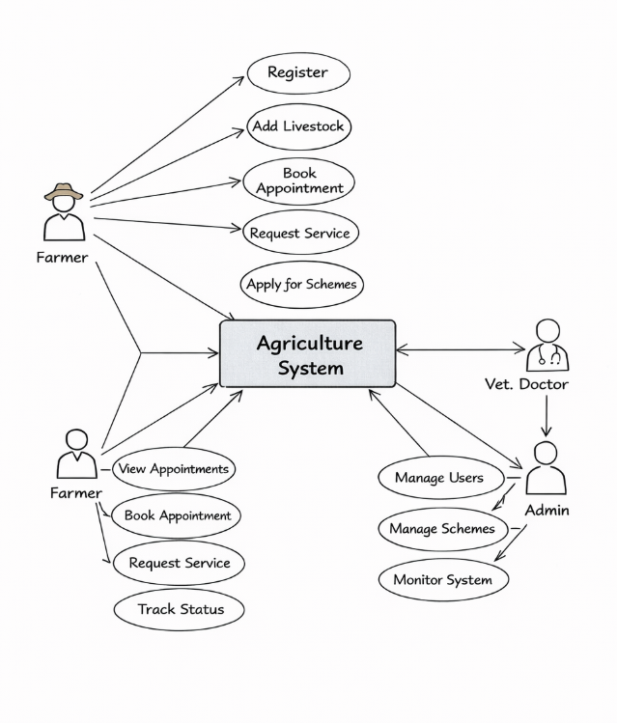

ACTIVITY DIAGRAM :

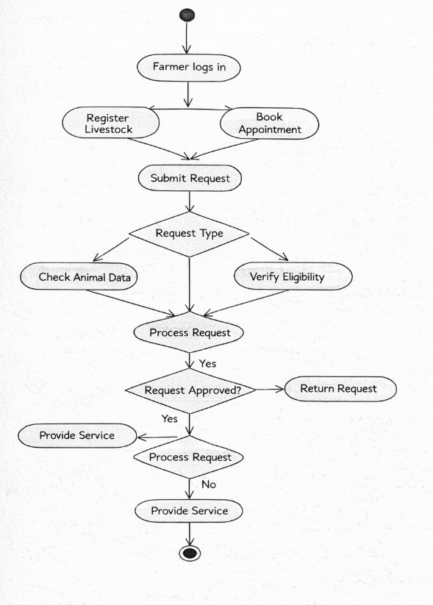

SEQUENCE DIAGRAM :

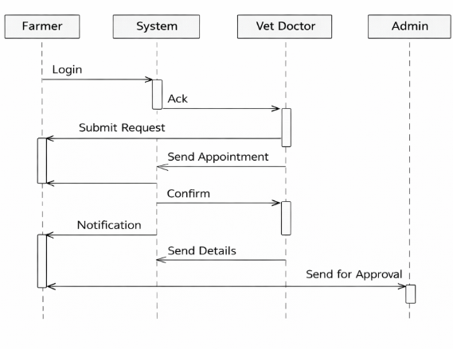
COLLABRATION DIAGRAM :

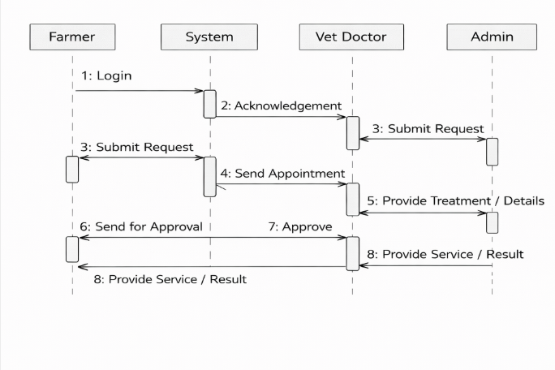

CLASS DIAGRAM :
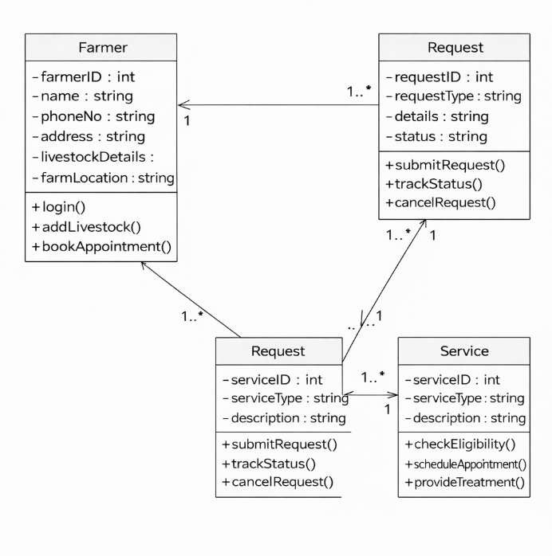

COMPONENT DIAGRAM :
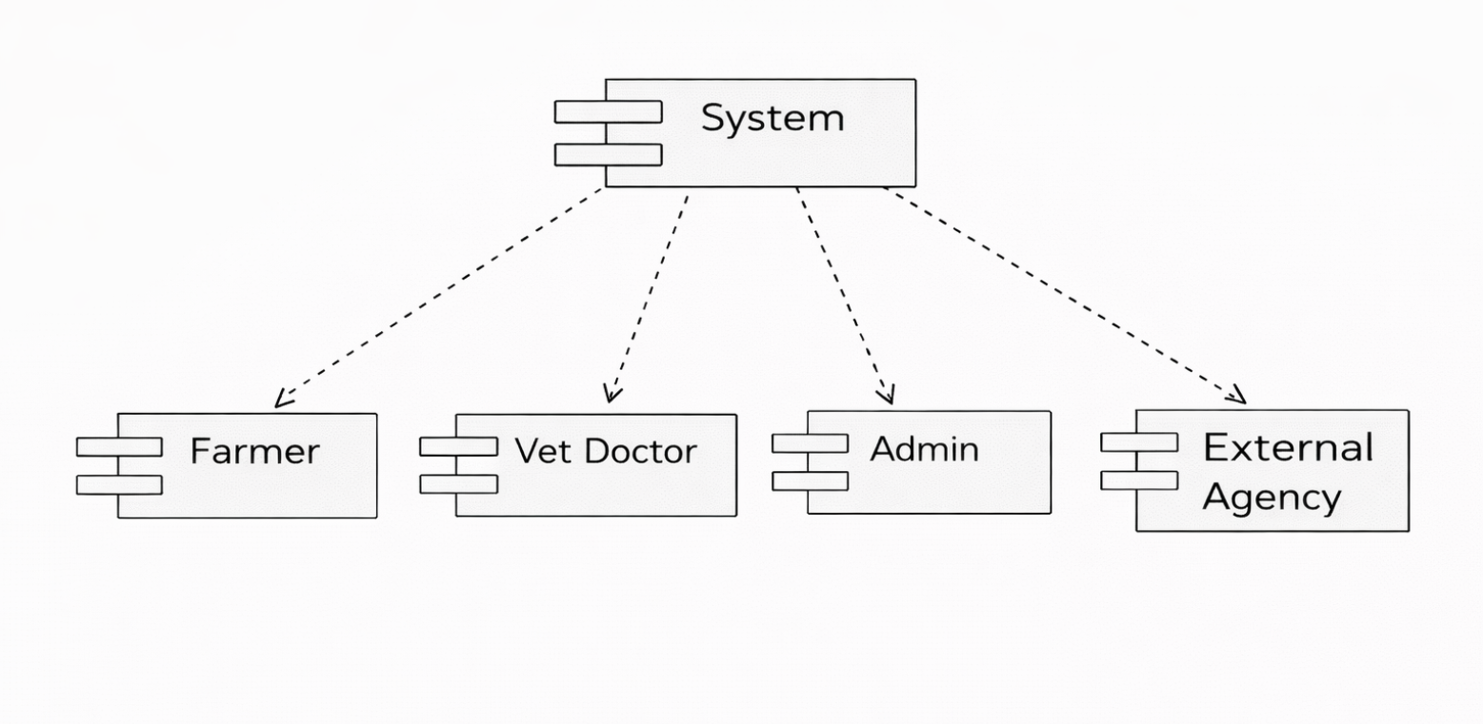

DEPLOYMENT PROGRAM :

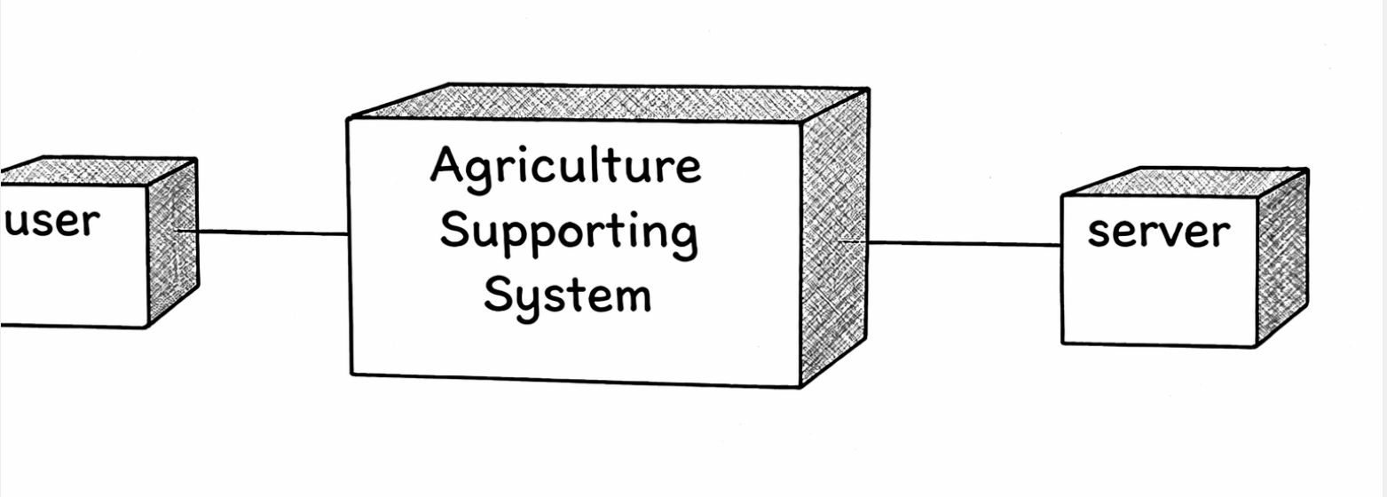

Implementation Phase :
The implementation phase involves developing and deploying the Agriculture Supporting System based on the design and requirements.
- The system is developed using suitable technologies such as Python (Django/Flask) or Java, with a web-based interface.
- A database (MySQL) is used to store farmer details, livestock data, appointments, and scheme information.
- Modules such as user registration, livestock management, appointment booking, and scheme application are implemented.
- The system is tested for functionality, performance, and security.
- After testing, the system is deployed on a server so that farmers can access it through mobile or web applications.
- Proper user authentication and data validation are ensured during implementation.

RESULT :
The Agriculture Supporting System was successfully implemented to help farmers access veterinary services and government schemes.It enables efficient livestock management, appointment booking, and real-time tracking of services.The system improves productivity, communication, and overall rural development.

